**Assignment – IV**

Name: Soumyadip Ghosh

Stream: CSE

Sec: A

Roll Number: 1951007

Gcov output

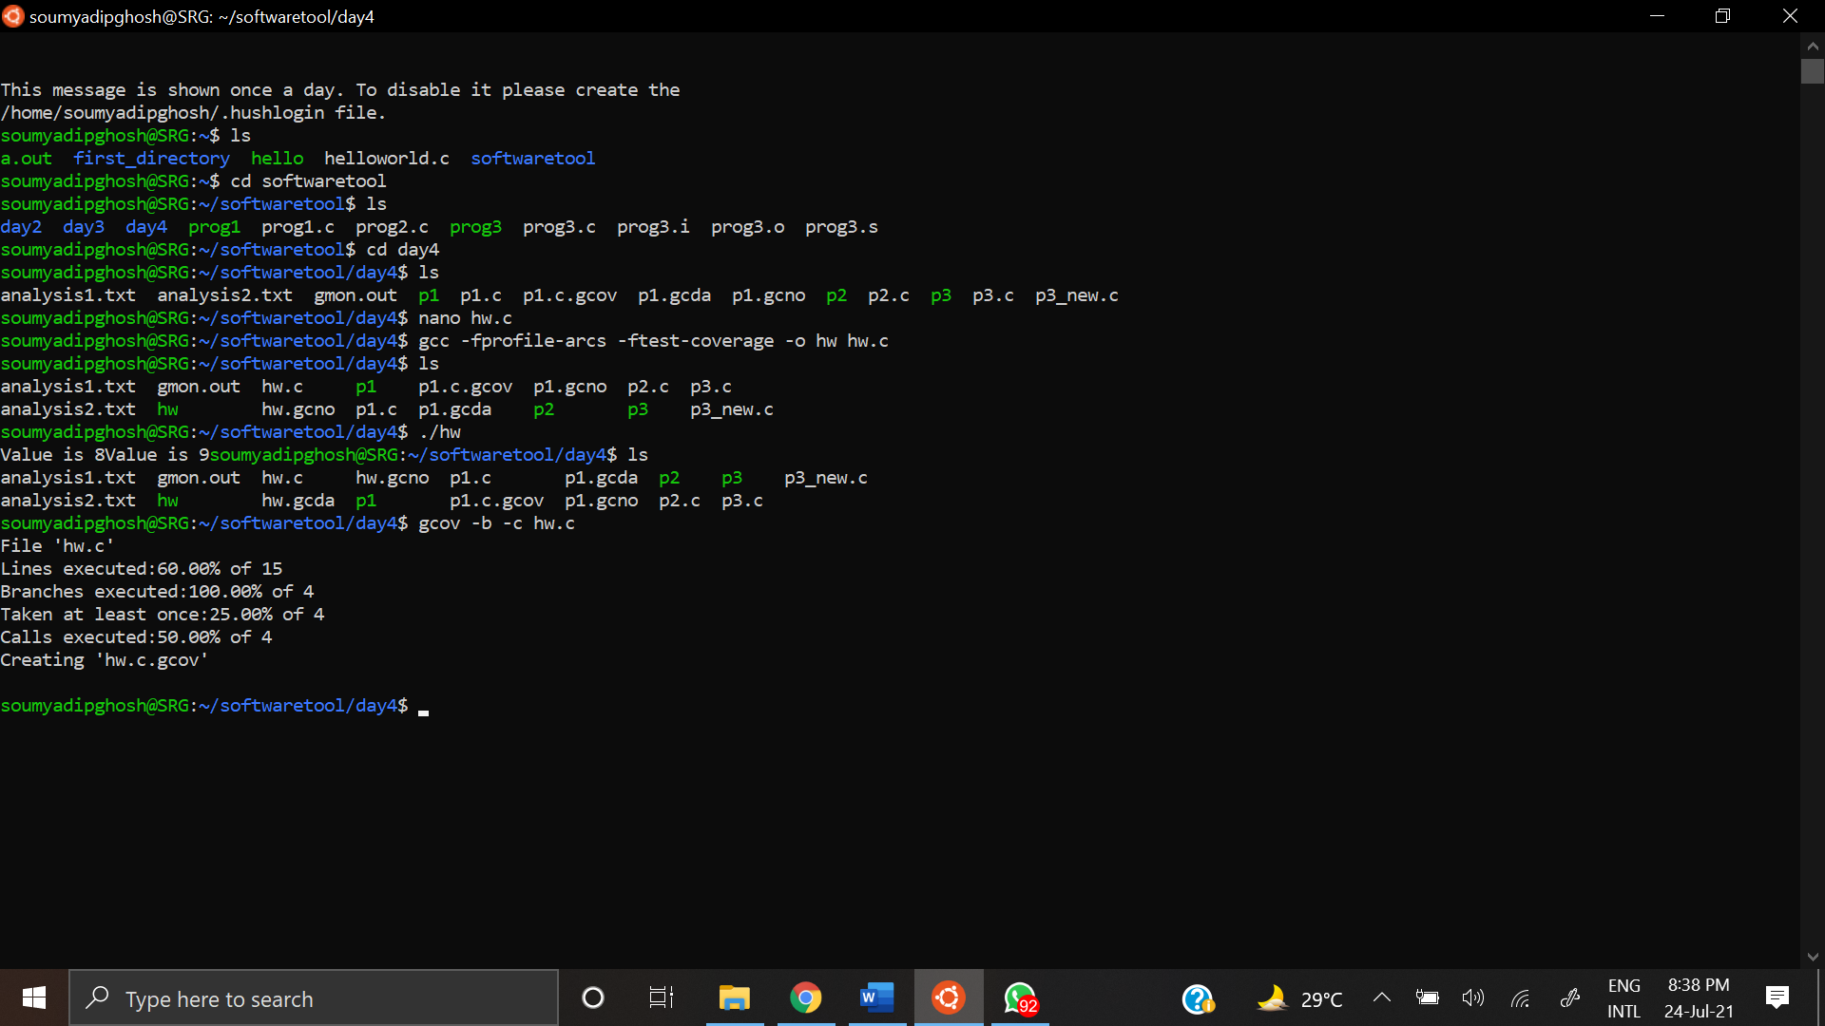

From this information we can see that 60 % of the lines have been executed i.e 9 out of 15 lines. All the 4 branches have been executed and 2 calls out of 4 (the cases in switch-case) were executed.

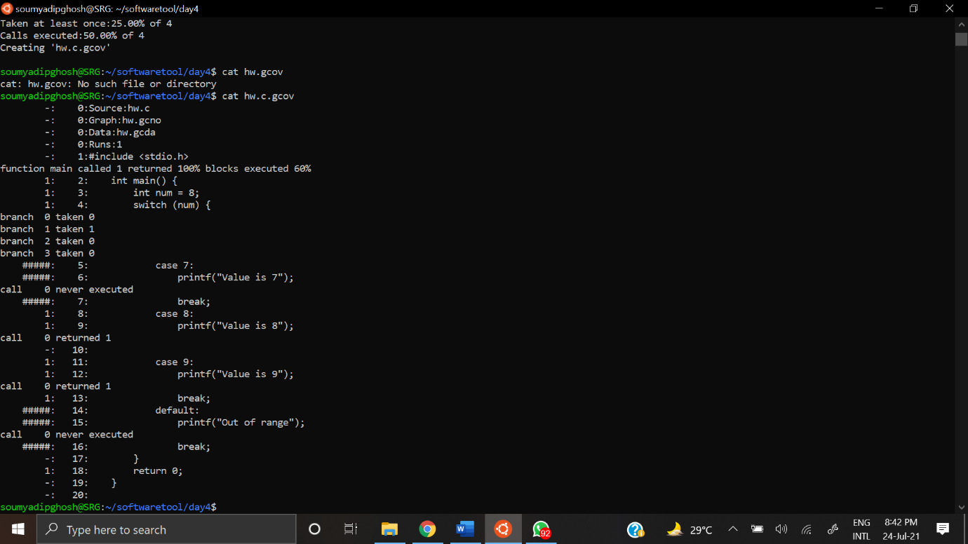

Using cat hw.c.gcov we obtain the following information . We can see the entries 1: before line numbers which indicates that particular line has been executed 1 time.

Call 0 never executed indicates that the previous line was not executed.

Call 0 returned 1 indicates that the previous line was executed successfully.

On the left hand side of the line number we can see the entries -: , 1: , #####: . The line numbers that contain ##### have never been executed while the lines containing 1: have been executed.